**Project Design Phase-II**

**Data Flow Diagram & User Stories**

| Date | 31 January 2025 |
| --- | --- |
| Team ID |  |
| Project Name |  |
| Maximum Marks | 4 Marks |

Data Flow Diagrams:  
  
In this context, the DFD represents how data is securely imported into ServiceNow using Import Sets, Transform Maps, MID Server for secure transmission, and ACLs for access control. The diagram will show external data sources, secure channels, import modules, and audit logging.

A Data Flow Diagram (DFD) is a traditional visual representation of the information flows within a system. A neat and clear DFD can depict the right amount of the system requirement graphically. It shows how data enters and leaves the system, what changes the information, and where data is stored.



**Example:** [**(Simplified)**](https://developer.ibm.com/patterns/visualize-unstructured-text/)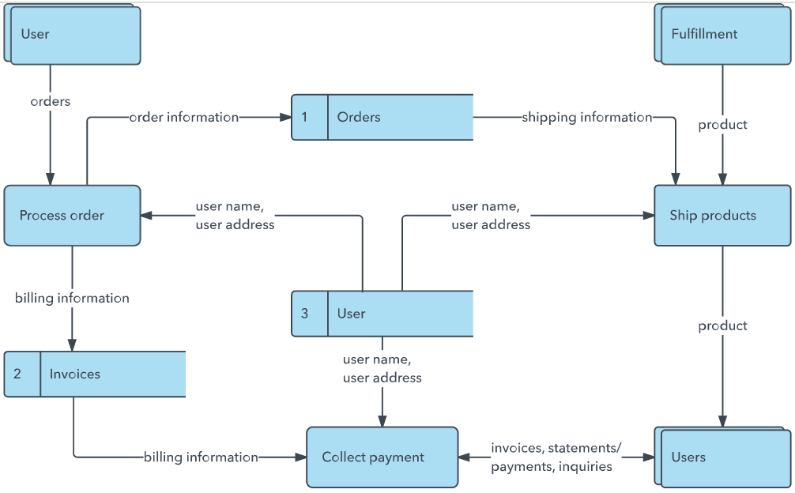

**User Stories**

Use the below template to list all the user stories for the product.

| **User Type** | **Functional Requirement (Epic)** | **User Story Number** | **User Story / Task** | **Acceptance criteria** | **Priority** | **Release** |
| --- | --- | --- | --- | --- | --- | --- |
| Administrator | Data Import Setup | USN-1 | As an admin, I can import data using CSV files into ServiceNow securely. | Data is successfully imported and appears in the target table. | High | Sprint-1 |
| Administrator | Data Validation | USN-2 | As an admin, I can use transform maps with scripts to validate incoming data. | Invalid records are flagged or rejected; clean data is imported. | High | Sprint-1 |
| Developer | Secure Transfer Setup | USN-3 | As a developer, I can configure a MID Server to enable secure data imports. | Data is transmitted through secure channels via MID Server. | Medium | Sprint-2 |
| Administrator | Access Control | USN-4 | As an admin, I can configure ACLs to restrict access to imported records. | Only users with proper roles can view imported data. | High | Sprint-2 |
| Compliance Officer | Audit Logging | USN-5 | As a compliance officer, I can review audit logs of data import activities. | Audit logs show detailed import events with timestamps and user actions. | Medium | Sprint-2 |
|  | Dashboard |  |  |  |  |  |
| Customer (Web user) |  |  |  |  |  |  |
| Customer Care Executive |  |  |  |  |  |  |
| Administrator |  |  |  |  |  |  |
|  |  |  |  |  |  |  |
|  |  |  |  |  |  |  |
|  |  |  |  |  |  |  |